  SNIR | Basic video worksheet  Computer Networking tutorial |   ESLA

Watch the video and answer the following questions:
- What is the router (ˈraʊtə) connected to?

The router is connected with the modem, and the users device can be connected with router.

- What are the two types of routers? What’s the difference of setting up? What’s the difference of use?

There is a wireless router, and a only wire router.

- What is the role of a router?

A router is a networking device that forwards data packets between computer networks.

- Reproduce the diagram representing the Home Network
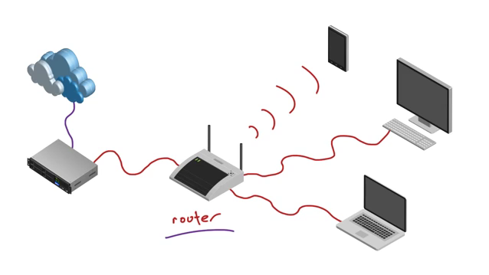
- Bonus question: Is a router enough to have access to the Internet? Explain.

A router is not enough. To have access to the Internet, we need a modem.

